

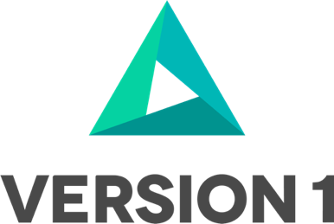

Maximise DM Dashboard

Technical Guide

@Copyright 2023 Version 1 – All Rights Reserved

Contents

1. Overview 4

1.1. About Maximise DM Dashboard 4

1.2. Terminology 4

1.3. What is not covered under Maximise DM Dashboard 4

2. Maximise DM DASHBOARD Overview 5

2.1. Design Flow 5

3. Maximise Technical SPECIFICATION 6

3.1. Business Entities/ Sub Entities 6

3.1.1. Finance 6

3.1.2. SCM 7

3.2. Maximise Core 7

3.2.1. Core Tables 7

3.2.2. Core Utilities 7

3.3. Maximise Extract 8

3.3.1. EBS - Extract 8

3.4. Maximise Transform 8

3.5. Maximise Import 9

3.5.1. Import Error and Success 9

**3.6. BIP Reports for Dashboard …………………………………………10**

4. Maximise OIC and VBCS………………………………………………….11

**Version Control**

|  |  |  |  |
| --- | --- | --- | --- |
| Date | Version | Changed By | Reason for Change |
| 26-JUNE-2023 | 0.1 | Sinchana Ramesh | No previous version |
|  |  |  |  |

**Circulation List**

|  |  |
| --- | --- |
| Name | Organisation/Title |
| Ken Mac Mahon | Version 1 |
| Bridget Morrissey | Version 1 |
| Praveen Nair | Version 1 |
|  |  |

# Overview

## About Maximise DM Dashboard

The Maximise DM Dashboard offers a comprehensive synopsis of the data extraction, transformation, and loading process from Oracle EBS to Oracle Fusion Cloud. This architecture comprises four tiles: Extract, Transform, Import, and Import Error, with the Detail table providing sub-entity counts being iteration field as mandatory. Additionally, the ETL process can be visually represented through graphical depictions. Currently, the dashboard is designed to support FIN & SCM modules, providing a clear summary of the ETL stages and the progress of data migration.

## Terminology

Some of the terminology used in this document and across Maximise DM Dashboard is shown below:

|  |  |
| --- | --- |
| Key | Description |
| Maximise DM | Maximise Data Migration accelerator |
| Business Entity | Refers to a Business Application Area e.g., Finance, HCM. |
| Sub Entity | Represents each level of data with Business Entity. |
| Migration Set Id | Maximise Term used to describe the group of all sub entity data being processed in a single execution for a specific business entity. e.g., AR, AP, GL. |
| Phase | Data Migration Phases – Extract, Transform and Import. |
| Extract | Extracting the data from source. |
| Transform | Transferring the data from stg table (source data) to xfm table (transformation table). |
| Import | Displays the number of records imported successfully into oracle fusion for each sub-entity. |
| Import Error | Displays the number of errored records during the import. |

## What is not covered under Maximise DM Dashboard

* Our Maximise DM Dashboard does not function for Non EBS, HCM & PPM Modules.

# Maximise DM DASHBOARD Overview

## Design Flow

This section outlines the Design Flow Diagram of Maximise DM Dashboard, illustrating how the data is displayed according to the provided input.

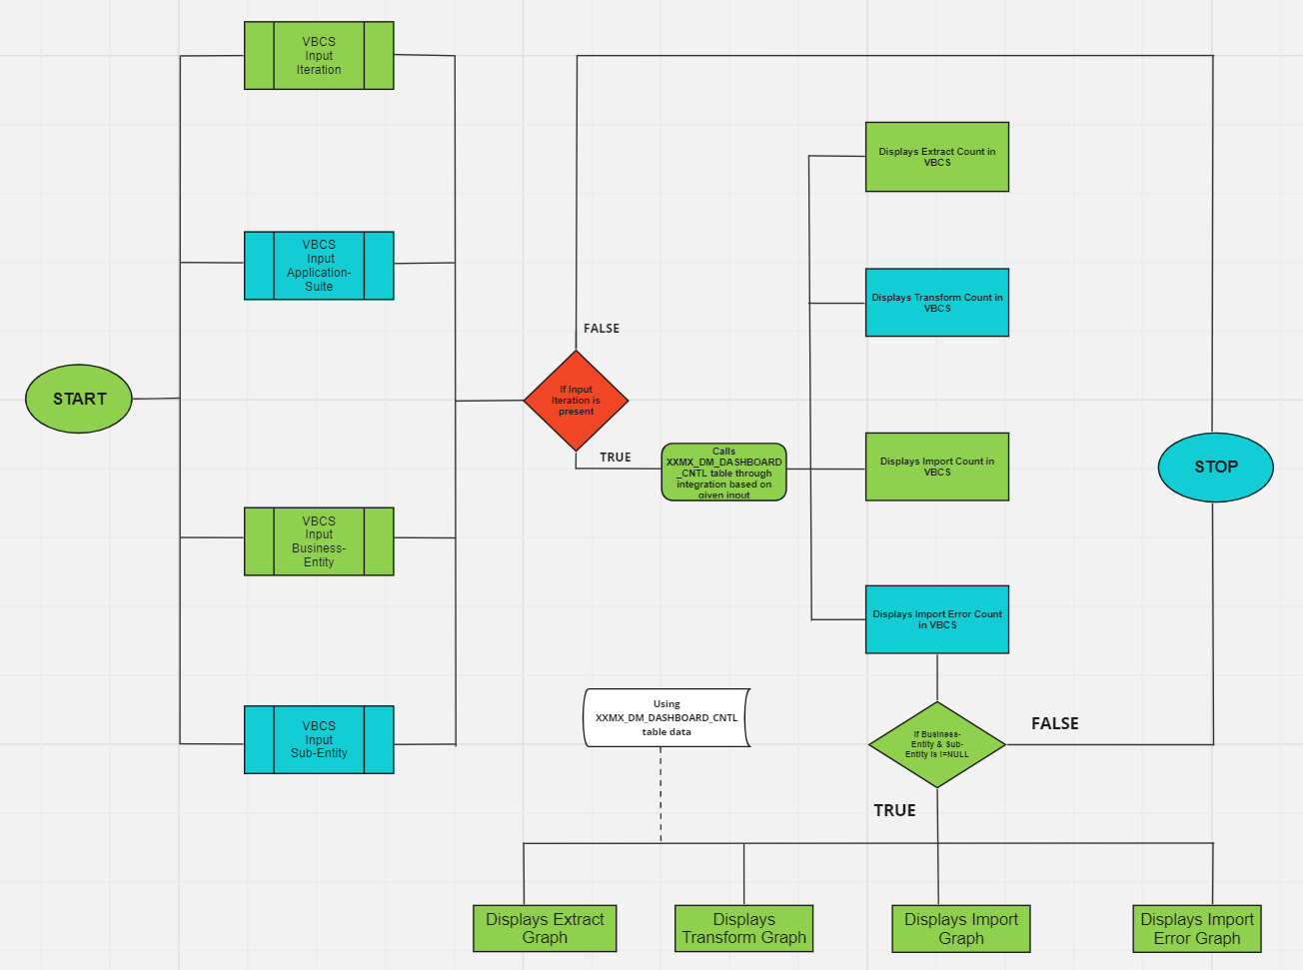

Figure 1 Maximise DM Dashboard Design Flow

# Maximise Technical SPECIFICATION

This section outlines the Business Entities and Sub Entities included in Maximise DM Dashboard.

## Business Entities/ Sub Entities

Maximise DM Dashboard covers the following modules/business areas - Finance and SCM and the key business and sub-entities covered under Maximise DM Dashboard are listed below.

**Note:** *Not all Modules are covered within Maximise DM Dashboard. Currently it works only for Finance and SCM Modules.*

## Finance

The table below shows a list of all business and sub-entities covered by Maximise DM Dashboard for Finance.

|  |  |
| --- | --- |
| Business Entity | Sub Entity |
| Suppliers | Suppliers |
| Supplier Addresses |
| Supplier Sites |
| Supplier Third Party Relationships |
| Supplier Site Assignments |
| Supplier Contacts |
| Supplier Contact Addresses |
| Supplier Payees |
| Supplier Bank Accounts |
| Supplier Payment Instrument Usages |
| Invoices | Invoice Headers |
| Invoice Lines |
| Fixed Assets | Mass Additions |
| Mass Distributions |
| Mass Rates |
| Customers | Parties |
| Party Sites |
| Party Site Uses |
| Customer Accounts |
| Customer Account Sites |
| Customer Account Site Uses |
| Customer Profiles |
| Locations |
| Relationships |
| Customer Account Contacts |
| Organization Contacts |
| Contact Roles |
| Contact Points |
| Person Language |
| Party Classifications |
| Roles and Responsibilities |
| Customer Account Relationships |
| Receipt Methods |
| Customer Bank Accounts |
| Journal | Journal |

## SCM

The table below shows a list of all business and sub-entities covered by Maximise DM Dashboard for SCM.

|  |  |
| --- | --- |
| Business Entity | Sub Entity |
| Purchase Orders | Headers |
| Lines |
| Line Locations |
| Distributions |

## Maximise Core

The Maximise DM Dashboard comprises four tiles: Extract, Transform, Import, and Import Error, alongside a Detail table that provides success and error counts related to sub-entities when the iteration is provided. To operate, all phases of the Maximise DM Dashboard rely on Core utilities and Core tables.

## Core Tables

The table below provides a list of core tables and descriptions for each. These tables are created as part of the Maximise DM Dashboard. These tables are populated as part of Maximise Installation.

|  |  |
| --- | --- |
| Table Name | Description |
| XXMX_DM_DASHBOARD_CNTL | This table holds Extract/Transform Fusion Error and Success Count related details based on Business Entity, Sub-Entity along with Start date and End date. |
| XXMX_DM_DASHBOARD_IMPORT_REQID | This table holds the number of Imported Records along with request_id. |
| XXMX_DM_DASHBOARD_CNTL_V | This view holds the latest migration_set_id details. |

## Core Utilities

**Note:** *Core Utilities should not be changed by the delivery/implementation team.*

During the Extract/Transform Phase these below procedures will be called, respective counts will be stored under the control table.

**XXMX_UTILITIES_PKG** has the below procedures.

|  |  |
| --- | --- |
| Procedure Name | Uses |
| insert_extract_control | Gets count based on business entity, migration_set_id, sub-entity, iteration during extract procedure/phase along with timestamp of extract start time/end time. |
| insert_transform_control | Gets count based on business entity, migration_set_id, sub-entity, iteration with respect to extract/transform procedure along with timestamp of transform start time/end time. |
| get_cumulative_counts | Gets cumulative counts for respective iteration, business entity, sub-entity, application-suite. |
| get_fusion_errCount | It provides import fusion error count with respect to iteration, business entity, sub-entity, application-suite. |
| convert_timezone_dashboard | It synchronizes the time-zones of Extract, Transform, and Import into one unified time-zone. |

## Maximise Extract

## EBS - Extract

The core utility package **XXMX_FIN_STG_EXTRACT_PKG** handles EBS customer database sources.

During Extraction, the extract package - **XXMX_FIN_STG_EXTRACT_PKG,** runs in background by calling the procedure "stg_main" will be initiated. The main procedure ***stg_main*** from the package calls relevant sub entity procedures, which are configured in **XXMX_MIGRATION_METADATA** table. It transfers the data from EBS sources to STG table. Once the data is inserted into STG table, it automatically runs the package - **XXMX_UTILITIES_PKG** this invokes the procedure **INSERT_EXTRACT_CONTROL** and inserts the extract count into the **EXTRACT_COUNT** column of the Maximise Control Tables - **XXMX_DM_DASHBOARD_CNTL** for that particular business-entity and sub-entity.

If the extract procedure fails at any point, the messages will be logged in the **XXMX_MODULE_MESSAGES** table.

## Maximise Transform

Transformations are usually done to transfer data from STG table to XFM table. Sub-entity transformations can be enabled or disabled in the **XXMX_MIGRATION_METADATA** database.

In the transformation phase, the utilities packages **XXMX_DYNAMIC_SQL_PKG** and **XXMX_UTILITIES_PKG** internally operate in the background. The main procedure **xfm_main** from this package calls relevant sub-entity procedures, which are configured in the **XXMX_MIGRATION_METADATA**. The procedure **transfer_stg_data** of **xxmx_dynamic_sql_pkg** gets invoked and transfers the data from stg table to xfm table. Once the transformation is completed within the same run it calls the procedure **insert_transform_control** of **xxmx_utilities_pkg** and inserts the transform count into the **TRANSFORM_COUNT** column of the Maximise Control Tables - **XXMX_DM_DASHBOARD_CNTL** for that particular business-entity and sub-entity.

If the transform procedure fails at any point, the messages will be logged in the **XXMX_MODULE_MESSAGES** table.

## Maximise Import

Once the data is extracted and transformed. when we import through **Maximise DM VBCS Application**. In this process, the request_id for the specific application-suite, business-entity, and sub-entity is recorded in the request_id column of the **XXMX_DM_DASHBOARD_IMPORT_REQID** table, marked as **'NEW'** state. To handle this data, there is a scheduled integration called-**INTDB555007 Schedule Import Error and Success Rpt**, which automatically runs every subsequent hour. This integration selects request_ids that are in the **'NEW'** state and not **NULL** from the request_id column of the **XXMX_DM_DASHBOARD_IMPORT_REQID** table. Once the request_id is identified, the integration triggers two subsequent integrations. The first one is **INTDB999003 Get Fusion Error Count and Details** - ERROR INTEGRATION, responsible for obtaining the count and details of any errors encountered during the import. The second integration is **INTDB999005 Import Count and Report** - SUCCESS INTEGRATION, responsible for determining the count of successful imports.

## Import Error and Success

* The schedule integration named **"INTDB555007 Schedule Import Error and Success Rpt"** is set to run automatically every subsequent hour.
* This integration retrieves request_ids from the **"XXMX_DM_DASHBOARD_IMPORT_REQID"** table, specifically those with a **'NEW'** state and a non-**NULL** condition.
* For each request_id in the integration, the BIP report provides information about its **IMPORT STATE**, **END_DATE**, and **TIMEZONE**. It utilizes the BIP report located at **"/Shared Folders/Custom/Maximise Data Migration/Request_ID Status"** within our fusion environment.
* The import request_id states are categorized as follows:

**STATE 10: 'ERROR'**

**STATE 11: 'WARNING'**

**STATE 4: 'COMPLETED'**

**STATE 12: 'SUCCEEDED'**

* The conditions for processing a request_id are as follows: If STATE is equal to 10.0 , 12.0 or 11.0, 4.0, any of these conditions being satisfied triggers further processing.
* After processing, the integration calls the child integrations, **INTDB999005 Import Count and Report** **&** **INTDB999003 Get Fusion Error Count and Details** for each request_id to get the Fusion Error count and Import Success count.
* In this child integration ,we have a look-up - **Fusion_Error_Report_Parameters_Dashboard** created in OIC . Which gives the absolute path of BIP reports to get the count.
* And the counts gets updated in the tables **"XXMX_DM_DASHBOARD_IMPORT_REQID" and “XXMX_DM_DASHBOARD_CNTL”** for that specific request_id.

## BIP Reports for Dashboard

The Error and Success Reports have been created in fusion to obtain counts for the dashboard.

VBCS Error Reports: **/Shared Folders/Custom/Maximise Data Migration/VBCS Error Reports**

VBCS Success Reports: **/Shared Folders/Custom/Maximise Data Migration/VBCS Success Reports**

# Maximise OIC and VBCS

Integrations are created to connect the VBCS application and database.

## OIC Components

List of OIC process called from VBCS Screen.

|  |  |
| --- | --- |
| OIC Process | Purpose |
| INTDB999005 Import Count and Report(1.0) | OIC Integration aims to retrieve the import success count and import details for the specific business entity and its sub-entity. |
| INTDB999002 Control Table Details for Dashboard(1.0) | OIC Integration retrieves the control table details - **XXMX_DM_DASHBOARD_CNTL** to display in the dashboard. |
| INTDB999001 Ext Trnsfrm Count for Dashboard(1.0) | OIC to generate extract and transform count for the specific business entity and sub-entity. |
| INTDB555006 Integration to get Report Count(1.0) | OIC to generate the BIP report for the specific business entity and sub-entity passed and retrieves the count. |
| INTDB555004 Display Import Error and Success Count(1.0) | OIC Integration to display the import error and success count from - **XXMX_DM_DASHBOARD_CNTL** in the dashboard. |
| INTDB999003 Get Fusion Error count and Details(1.0) | OIC Integration aims to retrieve the fusion error count and error details for the specific business entity and its sub-entity. |
| INTDB555007 Schedule Import Error and Success Rpt(1.0) | OIC to schedule the integration which runs every hour and picks the request_id which are ‘NEW’ and not NULL from the request_id table and updates the error and success count in **XXMX_DM_DASHBOARD_CNT & XXMX_DM_DASHBOARD_IMPORT_REQID.** |

## VBCS Components

**Web Applications created in VBCS**

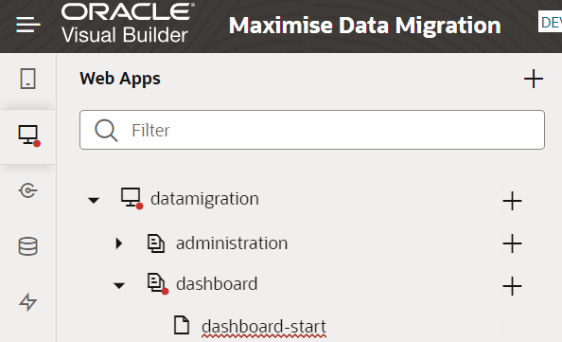

**All integrations are created as endpoints in VBCS.**

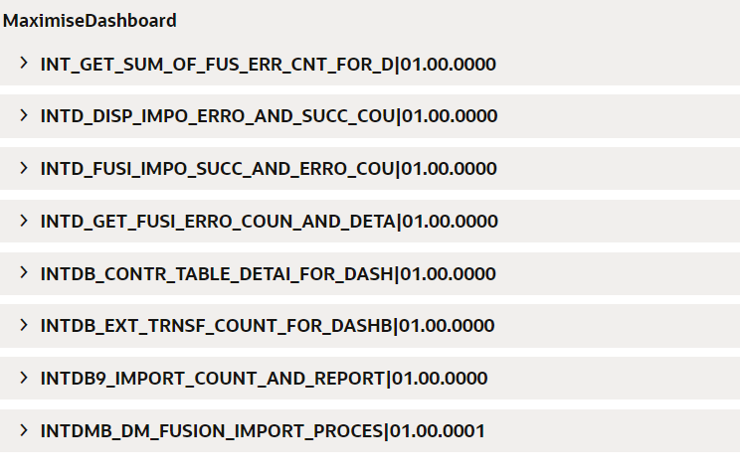

Business Objects Created in VBCS for **XXMX_MIGRATION_METADATA** Table.

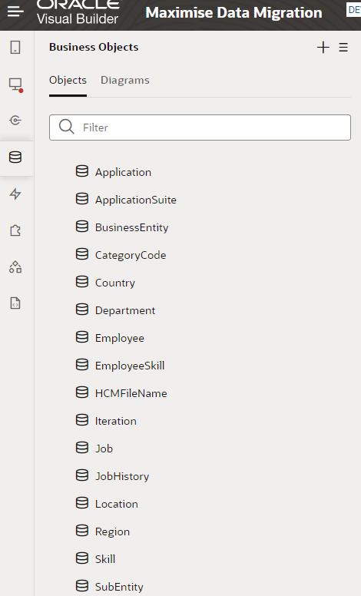

**Maximise DM Dashboard looks like below**

